Project name |  | Confidentiality level
Contract Management System |  | Public
Project ID | Version | Document code
01 | V1.01 | 02

Contract Management System
Project Planning



Copyright © Ruankosoft Technologies(Shenzhen), Co., Ltd.
. All Rights Reserved
Revision Record
Date | Revision Version | CR ID /Defect ID | Sec No. | Change Description | Author
5/23 | V1.01 | 01 | 01 | NULL | 15301014

Content
1. Project Introduction 4
2. Deliverables and Acceptance Criteria 4
3. WBS (Work Breakdown Structure) 4
4. Project Gantt Chart 5

Project Introduction
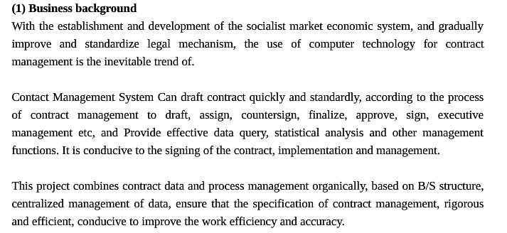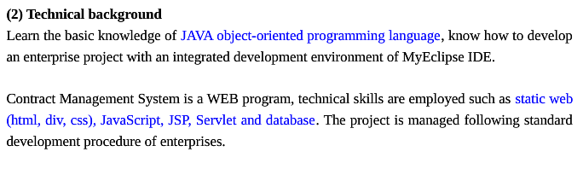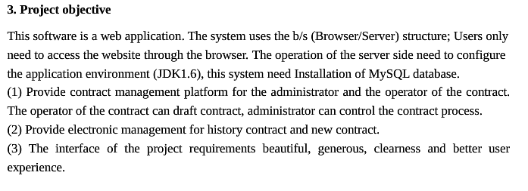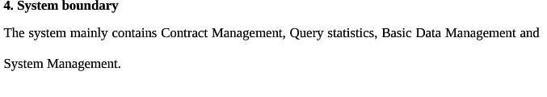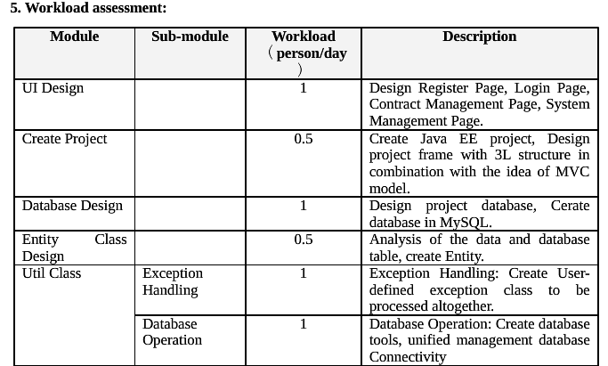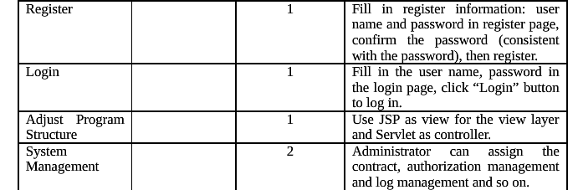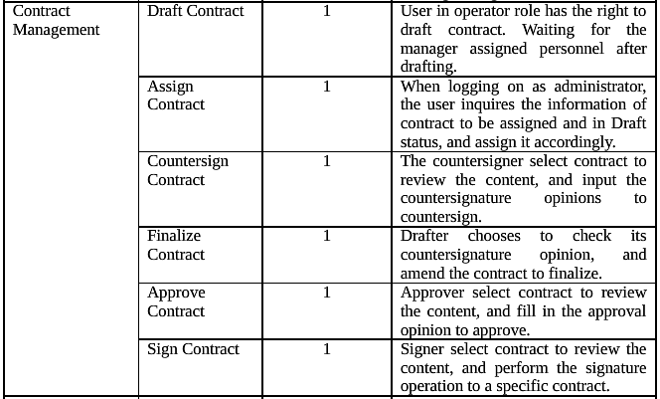

Deliverables and Acceptance Criteria
S.No. | Deliverable
01 | Project start report
02 | Project planning (Optional)
03 | Software requirement specification (Optional)
04 | System design specification (Optional)
05 | Final project code
06 | Project closure summary report
07 | Project user’s manual

WBS (Work Breakdown Structure)
S/N | Milestone stage | Work package | Workload(person/day) | Pre-task | Task difficulty | Responsible person
1 | Project Start stage | Project Start |  |  |  | 15301011
2 | Project Planning stage | Project Planning |  | Project Start |  | 15301014
3 | Requirement Analysis stage | Requirement Analysis |  | Project Planning |  | 15301018
4 | System Design stage | System Design |  | Requirement Analysis |  | 15301018
5 | Coding and Testing | Iteration 1 |  | Requirement Analysis and System Design |  | all
6 | Coding and Testing | Iteration 2 |  | Requirement Analysis and System Design |  | all
7 | Coding and Testing | Iteration 3 |  | Requirement Analysis and System Design |  | all
8 | Coding and Testing | … |  | Requirement Analysis and System Design |  | all
9 | Coding and Testing | Iteration N |  | Requirement Analysis and System Design |  | all
18 | Acceptance and Closure stage | Project Summary |  |  |  | all
Total of workload (person day):

Project Gantt Chart
S/N | Task Name | Time Limt | TIME
S/N | Task Name | Time Limt | XXXX year X month
S/N | Task Name | Time Limt | 1 | 2 | 3 | 4 | 5 | 6 | 7 | 8 | 9 | 10 | 11 | 12 | 13 | 14 | 15 | 16 | 17 | 18 | 19 | 20 | 21 | 22 | 23 | 24 | 25 | 26 | 27 | 28 | 29 | 30 | 31
1 | Project Start stage | 2
2 | Project Planning stage | 3
3 | Requirement Analysis stage | 4
4 | System Design stage | 2
5 | Iteration 1 | 5
6 | Iteration 2 | 2
7 | Iteration 3 | 3
 | … | 3
 | Iteration N | 3
 | Iteration 1 | 2
 | Acceptance and Closure stage | 3

